**+JavaScript Coding Test 1Hr**

1. Create a registration page as below. Use appropriate CSS and Bootstrap to create the page

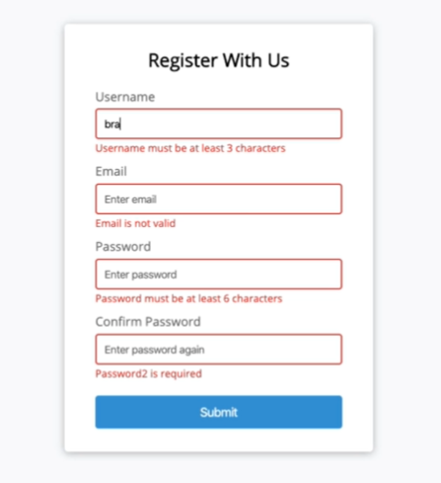

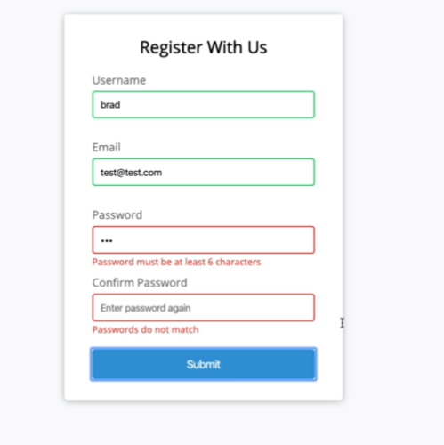

1. When user clicks on submit button the error messages are seen below each text box in red color and the text box border color is shown with red border.
2. Validate the above registration form with as per the below screen shot

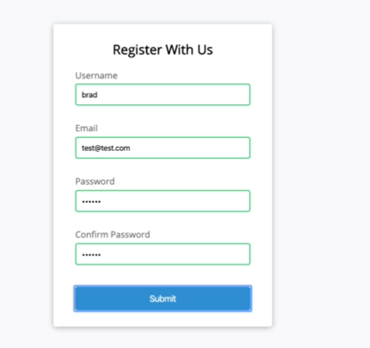

**PS: Submit the whole project folder by 8.00 PM today. Any submission beyond 8.00 pm today will be considered as not attempted.**

**Please follow the best practices while writing the code, best practices will carry 5 marks.**

**Maintain proper folder structure in the project, project folder structure will carry 5 marks**